**Guided Capstone Project Report**

**Bryan Spencer (github.com/brspencer90)**

Big Mountain Ski Resort currently boasts some of the best resort statistics in the US. Of the most important statistics related to ticket price, Big Mountain consistently ranks higher than other resorts (fast quads – top 5%, runs – top 7%, snow making area – top 15%, and vertical drop – top 10%).

|  |  |
| --- | --- |
|  |  |
|  |  |

Despite having the highest price in Montana, as well as within the top 19% of ticket price countrywide, based on the given data we see there is reason to increase the ticket price to reflect the overall market context.

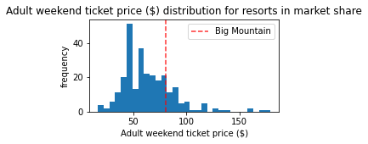

Our model has given us an expected set ticket price range from $85.48 to $106.26 based on current resort statistics. Given the current price of $81, even an increase to the minimum ticket price would result in a 5.5% increase in revenue ($7.8M over the season assuming 350,000 visitors and an average of five days on the mountain each).

As the objective of this was to find ways to maintain a profit margin with an increase in operating cost due to an additional chair lift, this is the simplest solution to achieve this goal. However, we have also identified other opportunities to increase the profit margin based on the data. We will go through the recommendations in detail below :

**Recommendations :**

1. Increase ticket price to $85.48 to realize immediate revenue increases by reflecting the value Big Mountain has in the larger US Ski Resort context. Based on results of this price increase on overall revenue, the price could increase to the upper bounds of the ticket price range given by the model ($85.48 to $106.26). Revenue will improve from $7.8M to $44.5M over the range of the suggested ticket price
2. Add a run, increasing the vertical drop by 150 feet, and installing an additional chair lift. Based on the predictive model, we expect this to increase ticket price by $1.99, an overall increase of nearly $3.5M in revenue. This will help improve long term profitability even after including a similar cost of $1.54M as the current additional chair lift.
3. Reduce or close off an existing run. This will have no impact on ticket price or revenue and may help bring in cost reductions. Areas with high maintenance costs, or snow making areas should be targeted in order to help improve overall profitability.

